**An analysis on luxury hotels in europe**

**Farahin Choudhury**

**Clayton Monroe**

**Syracuse University**

**IST707**

**INTRODUCTION:**

Throughout Europe there are many kinds of accommodations for tourists. The biggest cities across the continent draw some of the highest number of tourists, not just from within but also from all over the world. By virtue of the popularity of cities like London, Paris, Barcelona and Amsterdam, accommodations for every type of traveler need to be made available. These can include hotels, hostels and properties on home rental/sharing sites like Airbnb and VRBO. Each type of accommodation offers different experiences for travelers. They also range in price per night (not taking into account taxes and fees). Hostels tend to be the cheapest, whereas hotels can vary in price and are generally more expensive than hostels. Hotels themselves fall in categories such as resorts and luxury hotels.

Hotel properties can be part of a chain, under a hotel management company that owns several brands or they can be independent boutique hotels. As previously mentioned, hotels are priced differently based on many different characteristics. While location is a major factor in how a night at a given hotel is priced, other factors include proximity to public transit, proximity to tourist attractions, room amenities, prestige— what the hotel staff is like, the history and architecture – and ratings and reviews. Depending on the popularity of a hotel, it might need to be booked well in advance in order to secure accommodations for a trip. Hotel bookings are made possible in different avenues; tourists can book hotel rooms directly with the hotel itself or they can be booked on third-party sites like Expedia or Kayak, just to name a few popular sites. These sites also provide search results for hotels that have similarities in price and location which allow travelers to explore their options when booking their stay.

In recent years, travel websites and third-party sites such as Yelp, TripAdvisor and booking.com have proved to be a necessary asset in discovering and learning about business such as hotels. There is a lot of value that can be gathered from reading about other travelers’ experiences at hotels of interest to someone considering those specific hotels. Reviews for hotels tend to be very detailed and somewhat personal, which establishes a sense of trust between strangers on a platform that is treated like a public forum. Visitors to the site booking.com may choose to leave reviews on any hotel as long as it is on the site. Along with a written review, users can leave a rating from 1 to 10 stars. Ratings can also be provided for different categories such as value for money, cleanliness and location. These tend to be what travelers seek in their next hotel accommodations.

Luxury hotels appeal to a certain group of travelers. They are set apart from “traditional” hotels in the sense that there is a level of exclusivity to them. Not only are luxury hotels more expensive across the board, they offer different amenities and have different aesthetics in general. Hotel design and architecture contribute to the luster of a luxury property and in some cases it matters to a traveler who wants that experience. Despite the high cost and perhaps pompous clientele, luxury hotels are highly sought after. Hotels strive to attract all types of travelers but luxury hotels offer an experience that might only cater to a certain group of people. Price is a major factor but overall experience is important.

**ANALYSIS:**

1. The Data

The data contains reviews from previous hotel guests who have stayed at 1,493 different luxury hotels in various countries in Europe. In the dataset, there are both positive and negative reviews which are all in English, despite users being from different countries where English is not the primary or official language in those countries. This dataset was found on Kaggle and was of interest for this analysis because of the size of the dataset and the subject matter. There is a mix of numeric and text data which allows for interesting analyses. With over a half million observations, with each observation pertaining to a single review, the possibilities for different analyses seemed to abound.

There are a total of 17 variables in the dataset. These were explained in Kaggle which helped to brainstorm ideas for possible analyses methods and packages to use in R. Not only were both negative and positive reviews provided, the following data complemented the reviews: the numeric ratings (from 1 to 10), the total number of words for both the positive and negative reviews, tags associated with each review, the date the review was left on booking.com and the latitude and longitude coordinates, which were hardcoded. The coordinates would have been interesting to incorporate into the analysis, but map data that does not pertain to the US cannot be read into R studio with the packages that are currently available. Some other data that was not included in the analysis were the data for the number days since the review was left on the website and the number of reviews that only had a numeric rating as opposed to both a rating and a written review.

In preparing the data for the exploratory data analysis (EDA) process, the first step after importing the dataset is to learn about the type of variable that each variable is; this can take the form of numeric, character, integer or factor. The way this is performed is by using the str() expression. For this particular dataset, the variables were either characters or numeric. The next and probably most crucial step to prepare for EDA is to remove any records with missing data/NA values. If any NA values are introduced while running any line of code, an error will generate and interrupt the analysis.

1. Exploratory data analysis methods

Exploring a large data set is an interesting but challenging feat in a data analysis project. R studio makes it possible to import datasets of this volume to be manipulated and analyzed. The best approach to read in the data, which is a csv file, is to store the file in the working directory. Once the connection is established and dataset is read in, the data is ready to be explored. As previously mentioned, understanding the data is paramount to how the data should be processed and prepared. With regards to NA values in the dataset, they need to be removed so that a clean and successful analysis can be performed. In this data, there were 3,268 NA values, which is a small fraction of the 515,738 observations and thus would not impact the analysis for the project.

Since there were so many distinct reviews for the same hotels, a vital step in exploring this variable involves using the unique() expression in R. While the unique() expression was not used for positive and negative reviews, since each review was unique in and of itself, the hotel names and addresses were examined using this expression. Even though the data was fairly cleaned and the description of the data on Kaggle indicated the number of records, it’s an essential skill to find that value as a data analyst. In R, the use of vectors and objects makes locating and extracting data an easy task. This method was used to find how many records there were per hotel. The code can be repeated and replaced with each hotel name or address (using either variable would yield the same result since the outcome is a number).

Data can also be explored and summarized by creating visualizations. The next few visualizations were creating from the numeric data in the dataset. Using the hist() command creates basic but insightful histograms. These plots were made possible after removing NA values, otherwise R studio would return an error and no visualization would be generated.

The variable “Average_Score” is a numeric rating from 1 to 10 of each hotel property. The frequency is in the tens of thousands due to the number of records in this dataset. This histogram appears to have a normal distribution, with the shape emulating that of a bell curve, but the data is actually slightly skewed to the right. In this graph, the majority of the data falls between an average score of 8 and 9 out of 10, which is pretty high. The mean was calculated and it came out to about 8.4.



The variable “Reveiwer_Score” is another numeric variable that provides the rating each reviewer gave for the respective hotel. Just like the average score, the ratings are each on a scale from 1 to 10. The hist() expression was also used here to generate this visualization. The distribution of this data is a stark difference from the distribution of the Average_Score data in the previous histogram. In this histogram, majority of the data falls in the bin near ‘10’, which is the highest score a hotel can receive from a reviewer. The skewness to the right of this graph explains the skewness to the right of the Average_Score graph. The frequency is much higher for ratings of 10 in this graph.

The ggplot2 library was applied to generate the above visualization. ggplot2 is a powerful library with which many types of charts can be created. Unlike the simple histograms that were generated with few commands, the ggplot visualization is more aesthetically pleasing and eye-catching. The horizontal axis is not labeled appropriately but the score per reviewer is along that axis on this graph. Along the vertical axis, the total number of reviews that each reviewer gave on booking.com is provided. The color scale is a good indication of the frequency of the data. It’s difficult to tell that there are over 515,000 observations being depicted in this one graph alone but this volume of data can be handled with the appropriate code in R. The lighter blue shade is denoted by the higher end of the scale for Reviewer_Score, while the darker navy blue is denoted by the lower end of the scale and is not as present in the visualization. As with the histograms explained earlier, the data is skewed to the right; the higher the score, the lighter the shade of blue the plots are.

1. Clustering analysis

K-means clustering was used as a method to segment reviewers (customers) based on word usage. This is a valid means of segmenting the customer base because the words a customer uses in a review are a reflection of their priorities and how the hotel performed in areas related to their priority preferences. After trying several values for k, it was determined that k = 6 provided the best segmentation. A setback in the analysis was that for each value of k, a high majority of reviewers were classified into just one cluster. Setting k at 6 minimized this effect. While we do think with further refinement this may be an effective tool for segmenting a customer base, our current analysis ultimately fails to glean relevant insights. We would like to collect additional demographic information from customers in the future for use in a more effective clustering system.

1. Association rule mining

With this method, the Reviewer_Score data was utilized again to create buckets for the numerical ratings. Even though there were no ratings of zero (since that is not an option at all on booking.com), it was included as one of the breaks. The labels for these breaks are as follows: “terrible”, “below average”, “average”, “above average” and “exceptional”. It can be deduced that the ratings that fall into the “terrible” bucket are the low ratings and “exceptional” houses all the high ratings (anywhere from 9 to 10).

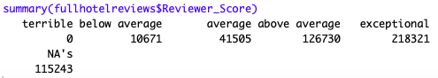

The above screenshot is the result from the code after creating the breaks in the data. A significant number of NA values are present but it is not the majority, which means the outcome of this analysis is still decent and meaningful. The theme of higher ratings being the majority is consistent here. The ggplot visualization as well as the two histograms from before showed a right-skewed graph, and the number under “exceptional” is the highest here.

1. Text mining

This method was the most challenging out of all the data analysis methods. This method was attempted because it would be negligent to disregard for this analysis considering how much text data is present in the dataset. The libraries in R needed for text mining are tm e1071, and quanteda. There are various packages and expressions associated with these libraries that offer different methods of exploring and yielding insights regarding text data. For text mining, some of the variables needed to be converted to factor data. This is performed by using the as.factor() expression in R.

**RESULTS:**

Clustering

In processing the data to create clusters for a specific hotel in the dataset, Hotel Arena, words for both positive and negative reviews for this hotel were gathered to find the frequency of those words. While this is an example for only one hotel, the same concept applies for all the other hotels. It might seem obvious that the most frequently occurring word in this graph is “room”, but it is very intuitive. Hotels are based on the rooms themselves, not necessarily the entire property which may include the lobby or other common areas.

Association rule mining

Even with cleaned data, the results from association rule mining included NA values which is not ideal. Despite NAs occurring after the execution of the code, rules were still created and a visualization got created.

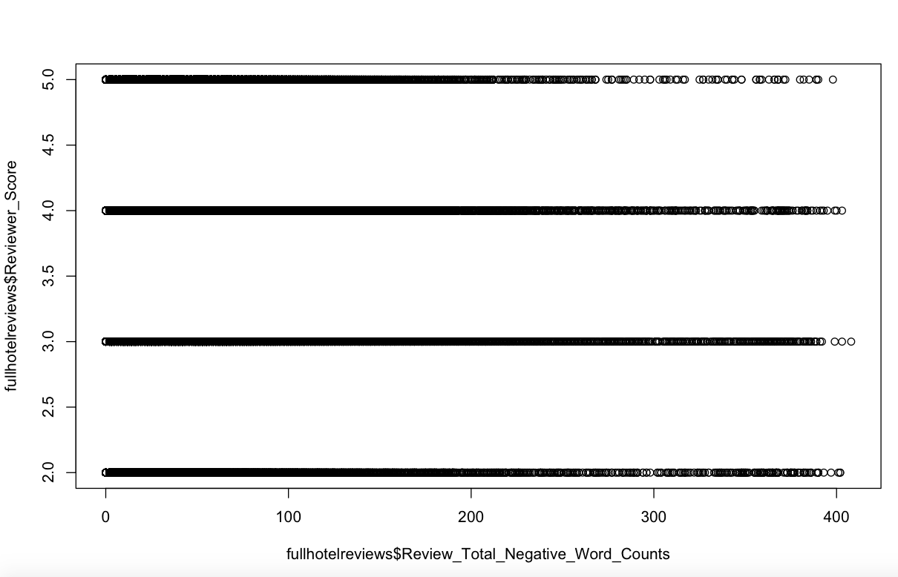

This visualization is not quite intuitive nor does it capture the various buckets that were created. This graph introduces the number of words in negative reviews. The graph for total number of words in positive reviews is nearly identical when compared against the Reviewer_Score data. The rules seem to be bunched up which makes it difficult to understand visually and conceptually.

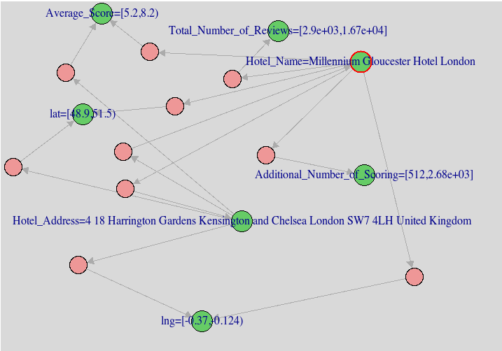

This is an example of one of the rules that were generated which is done using the apriori() expression. There were over 13,000 rules generated and not all of could have possibly been plotted all at once. Again, this plot does not appear to be as intuitive but perhaps it is due to the rule that apriori generated. It is a time-consuming process to examine over 13,000 rules, but at least R can be instrumental for this kind of machine learning model.

Text mining

The word cloud results for a specific hotel are depicted below. The first word cloud depicts word frequencies in the negative reviews and the second word cloud depicts word frequencies in the positive reviews. The size of the word in the word cloud corresponds to how often the word appears in a review; the more often the word appears, the bigger the word in the word cloud. In both the positive and negative reviews, the word “room” occurs quite often, whereas “rooms” occurs much less often. This might seem surprising as “room” and “rooms” are essentially the same word. Another interesting finding from these visualizations is that the word “bed” seems to occur more frequently in positive reviews than in negative reviews.

***Negative for “Hotel Arena”***

***Positive for “Hotel Arena”***

**CONCLUSION:**

This project highlighted the challenges in working with a large volume of data. Not all the methods used for this analysis yielded useful or interesting results. Even with a dataset that seemed clean and prepared for analysis, it needed additional preprocessing and cleaning, as most data do. This applies to both structured and unstructured data, with the latter requiring more finesse and time. A large dataset presents challenges of its own by virtue of its size. With so much data, upon first glance it’s difficult to gauge how to navigate it. This is why making sure the data is prepared and processed for analysis is crucial.

For this analysis, there could have been other data that proved to be more useful to gain stronger insights. For example, some additional data that would be ideal for this analysis are whether the reviewer was male or female, the length of the stay per reviewer (measured in number of days), and whether it was the first time the reviewer stayed at a specific hotel. More interesting and meaningful associations and insights could have been generated. More relevant numeric data would allow for more eye-catching charts to be created, not for the sole purpose of being eye-catching. In addition to visualizations, this additional data would work better with the models created under association rule mining and clustering analysis.

Traveling is a luxury in and of itself. No matter how often someone travels, they are impacted by the hotel industry as tourists in a different country. People are increasingly relying on reviews and ratings to make informed decisions on the kind of accommodation to stay in and where to stay. This type of data could be found on other travel related sites and services such as TripAdvisor and Kayak. Scraping data from those sites and comparing the data extracted from booking.com might be a next step in a deeper analysis. As travel enthusiasts, it is important to take into account others’ experiences to either replicate or avoid them altogether. No two experiences will ever be the same, just like no two reviews (either positive or negative) were the same in this data. People seek different experiences and goals when traveling and this data seemed to have captured that.